Learning diary

**Week 1**

On week one we only had meeting to discuss our project and we found ourselves a great plan. We want to make an automatic blinds closer/opener. We will need stepper motor, Arduino and casing for the device. Our plan should be easy making and we think that we will not have any major problems.

Also, at we prepared and trained skills to make this project work on our own ways. Some of us were on the lessons and some prepared their own way.

**Week 2**

Week two we could not get any real work done on our project because other school projects and work, but some of us were on the lectures again and honed our skills at 2D and 3D fabrication. Others worked and prepared their selves on their own ways.

**Week 3**

Preparation for mid-term presentation and the presentation. Also, schedueling our next moves. Some 3D modeling

**Week 4**

Week four we started to really get our heads together and push the project as far as we can. And we did just that. We got together on discord one day and just started to work. That night we worked hard, fast and long. We got the 3D model finished. In tinkercad we started our wiring and then started to code the Arduino. Hard part was to get breadboard to work correctly. Breadboards were new to few of us.

**Week 5**

Learning more about coding and trying to get our code to work. Problems occurred were with the coding language, these problems were fixed with a quick google search. Started to plan the final presentation.

**Week 6**

Working on the final presentation and trying to get the sensors working on Arduino. Problem was to get the stepper motor to not spin at 9000 rpm that’s just too much for our project.

Overall, not many problems just a small things with the code and those problems were easy to fix with tweaks on the code. Biggest problem of this project was to find time together to do this.

**Softwares used**

* Tinkercad
* Autodesk Fusion 360

**Hardware**

* Arduino Uno
* Stepper motor
* Pir sensor
* H-bridge L293D
* Our 3D model
* Blinds to control

**Pictures of the project**

First sketch of the product (Week 1)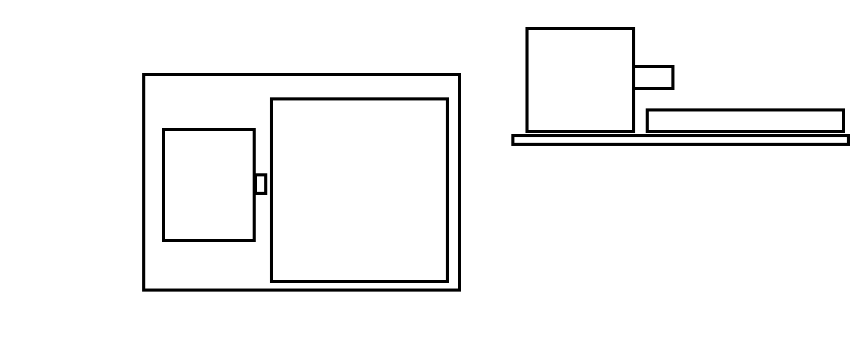

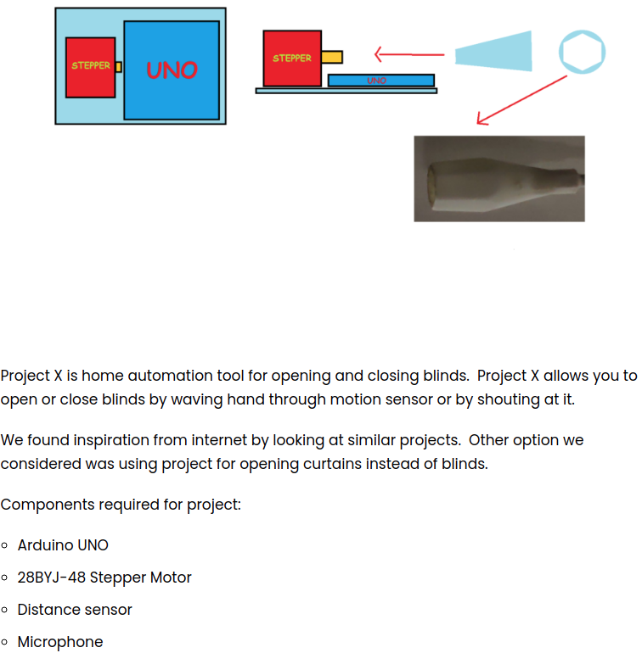

Very early motor trials (week 3 and 4)

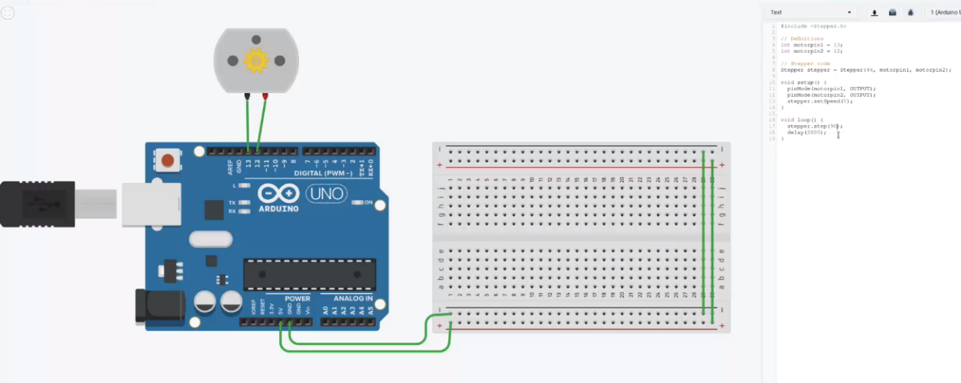

Finished 3D model of the connector to the blinds control (week 3 and 4)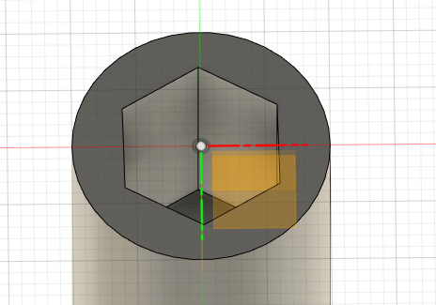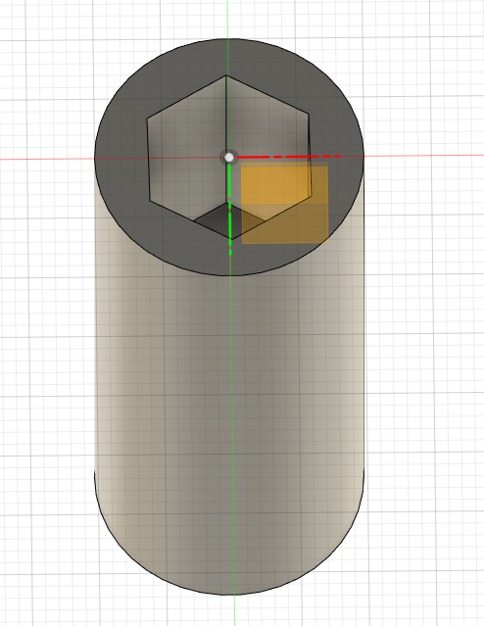

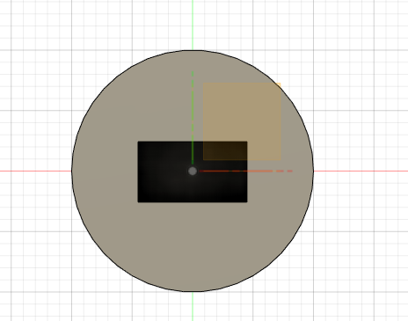

3D models of the casing (week 3 and 4)

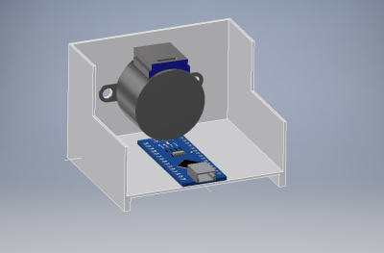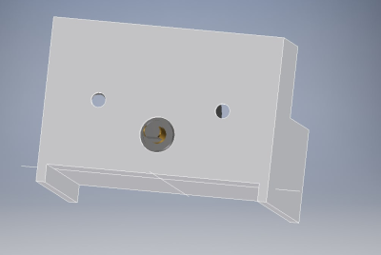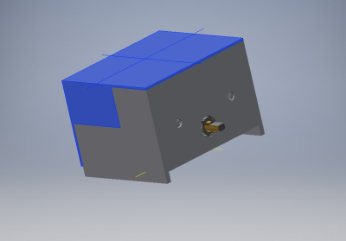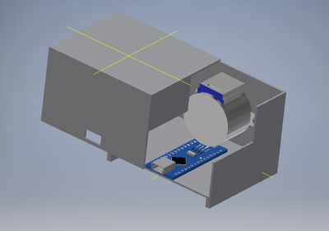

Closer to the finished thing (Week 5 and 6) (motor did not work so went back to the other motor)

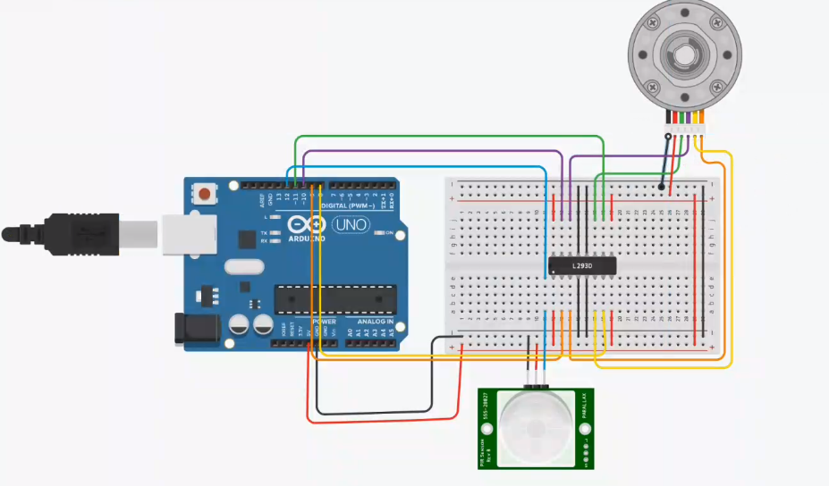

**What’s next**

If we could have gotten the components and more time the prototype would be finished and working. The problems with prototype would have been the resistance between motor and the blinds. Some tweaks to code and then it would have probably work.